The machine operator is responsible for selecting data for the diameter of the item to be threaded, the tool/thread angle and the depth of thread to be cut. Refer to a data source e.g. Zeus Book.
The ‘leadscrew’ only moves the saddle, toolpost with the along the bed of the lathe.

The ‘feedshaft’ (plain bar with single keyway) is responsible for sliding/traversing feed and/or facing off.
The ‘Stud Gear’ for a particular selection is made by replacing whatever is fitted in the stud gear (a stack of gears A-G) with the gear as listed on the plaque. They are identified by letter and should be held on a parking stud under the gear train end cover.
The ‘Rotary Dial Selector’ reading is the number on the rotary selector (1 to 5). Note that the Gear Engagement lever (vertically moving lever on the left of gearbox) must be selected with the same number (1 to 5) as the Rotary Dial Selector).
The ‘Top lever’ mounted on the top of the gearbox gives three speed selections of Left, Centre & Right.
The ‘Quadrant sliding gear’ is the knurled knob under the gear train cover which slides two combined gears in and out of mesh on the drive gear(s) to the input to the gearbox shaft. Push/pull it horizontally to make it either ‘in’ or ‘out’.
The three figures given on the rightmost column are, from the top down, for
- Threading (Driven from the leadscrew)
- Sliding/traversing - cutting an outside diameter of a shaft (Driven from the feedshaft)
- Facing off - cutting the face of a bar or disc (Driven from the feedshaft)
Note that b) and c) don't use the leadscrew but use the feedshaft and require the appropriate selections to be made from the leadscrew/feedshaft lever.
Refering to the chart/plaque below, to screwcut, say a thread of 1.5mm pitch, locate 1.5mm on the plate/plaque, then go up the columns to the top and then to the left and work your way down. This indicates that the top lever has to be set to right and the quadrant sliding gear needs to be in.
Stud gear – fit gear D. On the end plate should be a stack of gears A-G, find D and fit it in the stud gear position.
Rotary Selector Dial - select 1 (round dial on the front of the gearbox).
Gear Engagement lever - select 1 (vertical moving lever on the left of gearbox)
Quadrant sliding gear - push in. On the gear-train assembly, you push/slide the knurled knob IN. It has 2 gears behind it, 1 small + 1 larger gear. (Push inwards = IN : Pull outwards = OUT)
The top lever - choose right (the left lever can be in the left, middle or right positions).

Note: - the same setting would give 0.468mm/rev for sliding/traversing feed and 0.180mm/rev facing-off feed if the feedshaft lever was engaged (change lever from leadscrew to feedshaft for this option).
Note: - you must also move the right lever to select screwcutting, so that the leadscrew (threaded shaft) turns when the lathe is running.
Now you will cut a 1.5mm pitch thread when you engage the leadscrew via the screwcutting engagement lever with its split not mechanism.

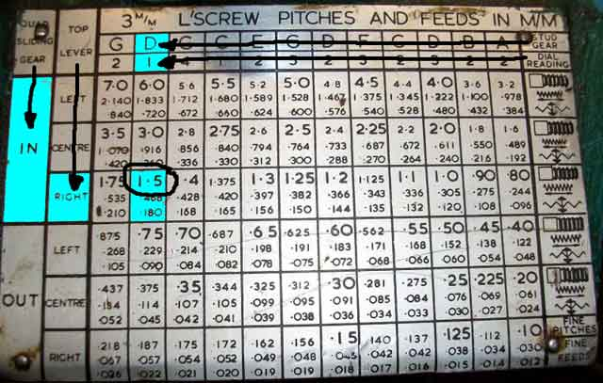

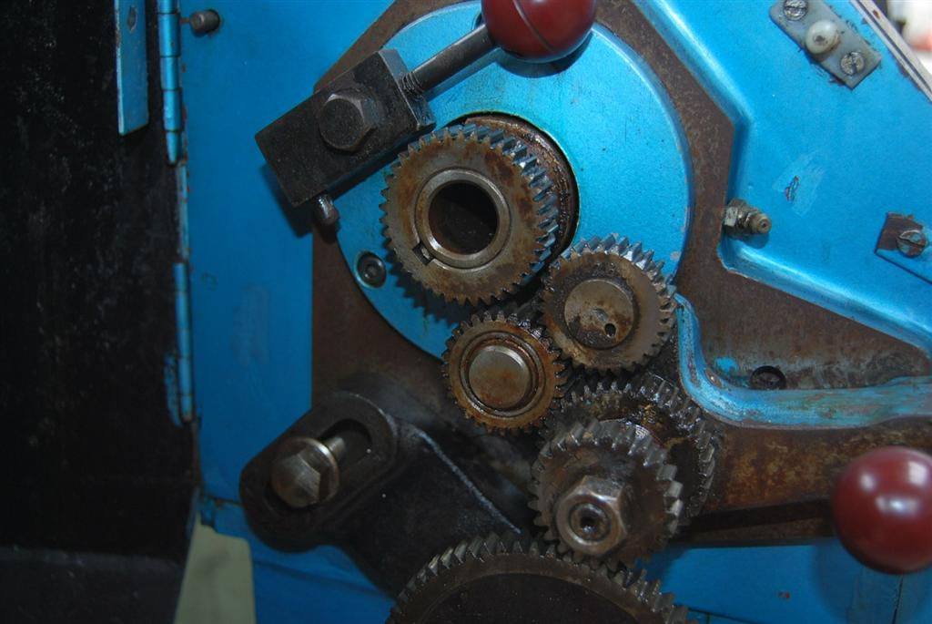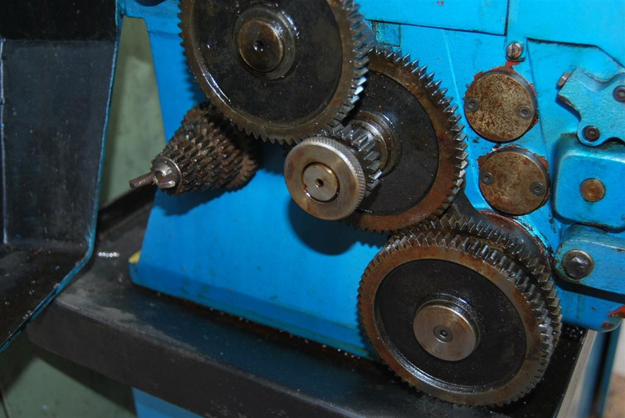

QUADRANT SLIDING GEAR
SPUR GEAR

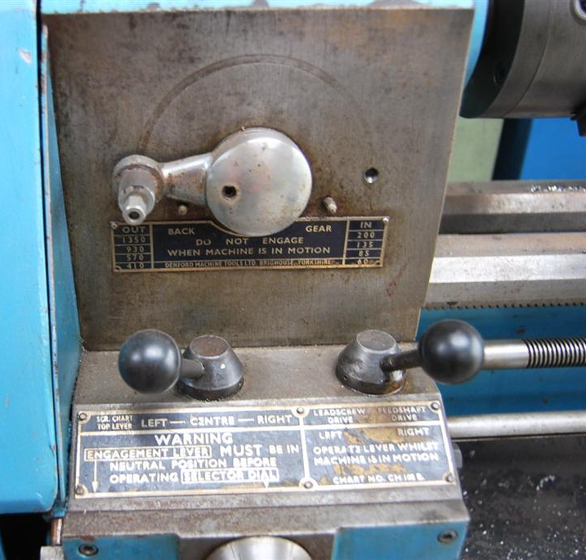
Feedshaft
Leadscrew
Leadscrew – Feedshaft Lever
Left – Centre – Right Lever
SPUR GEARS
A to G
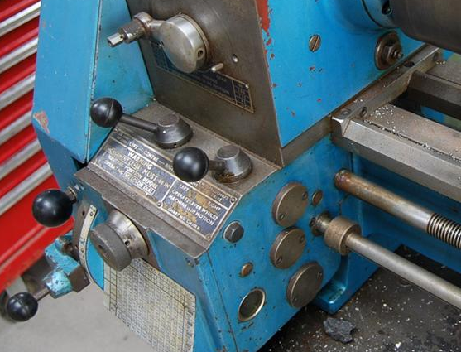
NOTE: numbers on both must be the same i.e. 1 & 1, 2 & 2 etc.

Gear Engagement lever
Rotary Selector Dial



