Setting up a MicroTurn with Recommended Tooling

Set Up QuickTURN 2D Design
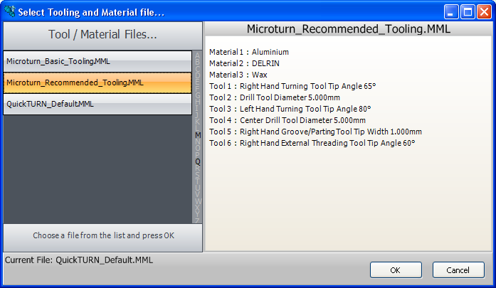

Open the QuickTURN software and select the “OPTIONS” menu

Then select “Load Tooling / Materials” and select the MicroTurn Recommended Tooling.

Then select OK

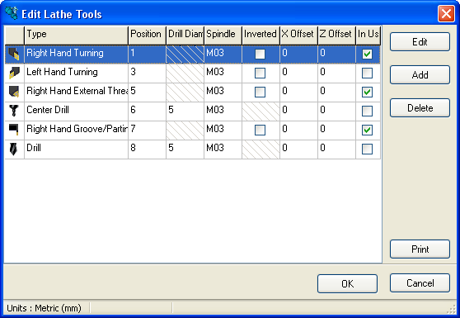
You now need to enable the tooling you have fitted to the toolholders and want to use with the machine.

In this case we need to enable the turning tool, threading tool and parting tool. This is done by ticking the in use box for each tool.

Setting up the Workpiece offset

The Workpiece offset defines where the centre line and the end face of the billet is so that when a tool is positioned in the centre of the face of the billet the coordinates read X=0 and z = 0.
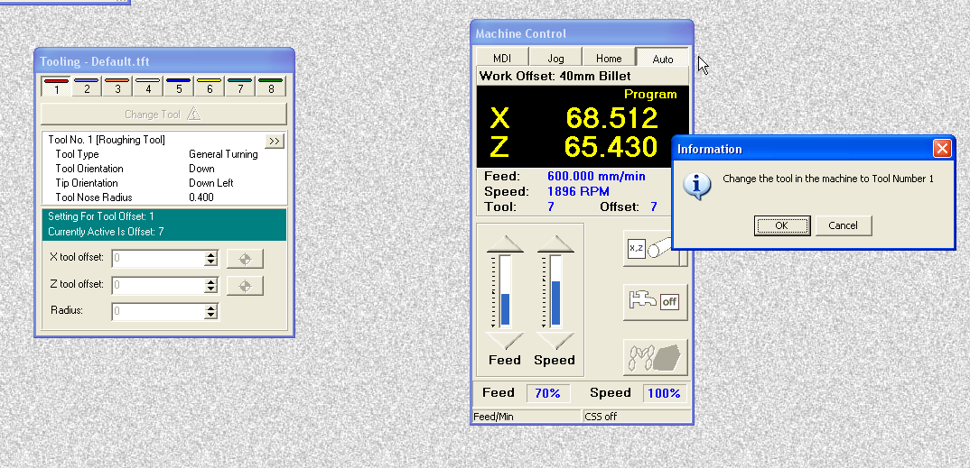

The workpiece offset is set using tool 1 as the reference.

The first thing to do is to Home the machine, then select AUTO mode. Then open the tooling window, select tool 1 and toolchange. Click OK.

Then open the Workpiece offset menu.
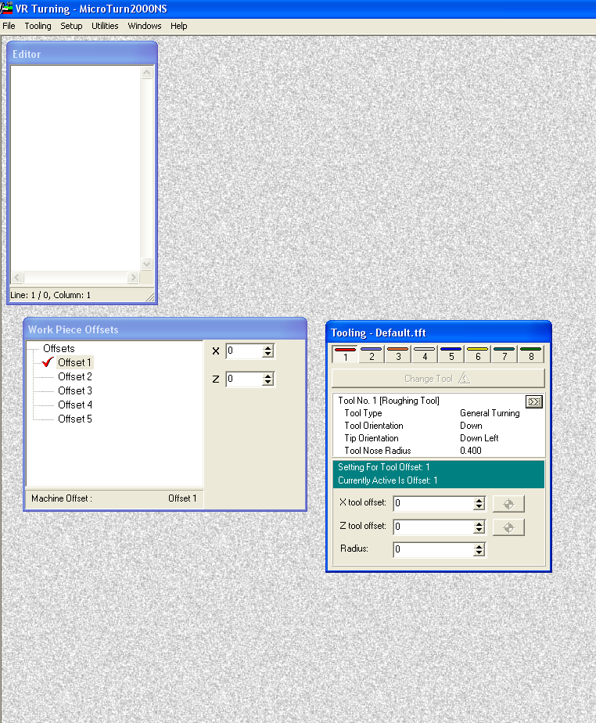

Ensure Tool 1 is the active tool in the tooling menu.

Also Ensure the tool Offset for both X and Z is set to zero.

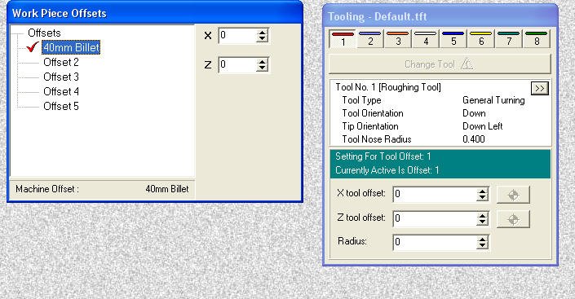
Select Offset 1 and rename it “40mm Billet”

Now fit a billet into the chuck and measure it accurately so that is sticks out exactly 40mm.
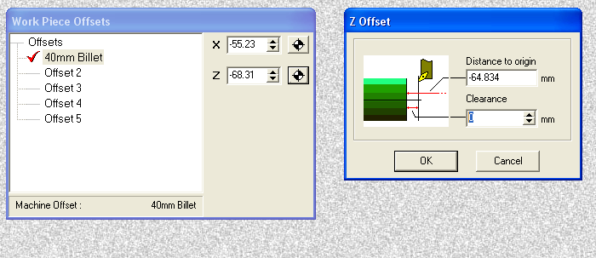

Select jog mode and start the spindle at about 2000RPM (using the M code command).

Jog the axes and take a very light facing cut down the part so that the tool is on the face of the material 40mm from the chuck.

Click on the Datum symbol to the right of the Z display and put a value of zero into the box labelled clearance then Click OK. The display in the control panel will now show a program position of zero.

Next we will set the X Datum position.

The X axis position is displayed in diameter values. So when the tool is at the centre of the part it displays 0 but when the tool moves 5 mm away the diameter and display will be 10mm.
With the spindle still running take a light turning cut from the bar diameter then jog away in the z axis only so the tool tip is still at the same diameter as the turned part.
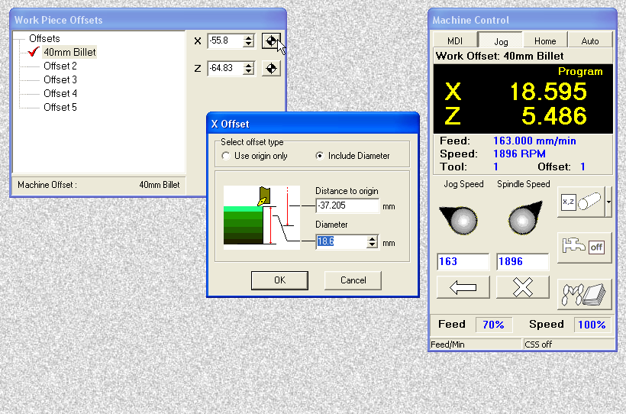

Stop the spindle open the guard and measure the turned diameter accurately.

Click on the Datum symbol to the right of the X display
Measure the exact diameter that has been turned and then enter it into the box labelled diameter. Click OK. The display in the control panel will now show a program position in X of the diameter you have input.

Tool 1 is now set and provided the billet is always set 40mm from the chuck this will not have to be done again.

If billets of different lengths are to be used then repeat this procedure renaming and setting Offset2, 3, 4 etc.

All the other offsets are set in relation to tool 1 so will not require resetting even if the billet length changes.

Setting tool Offsets

Leave the billet used to set up the Workpiece offset in the chuck. (This is set to stick out 40mm)
To set up the threading tool:
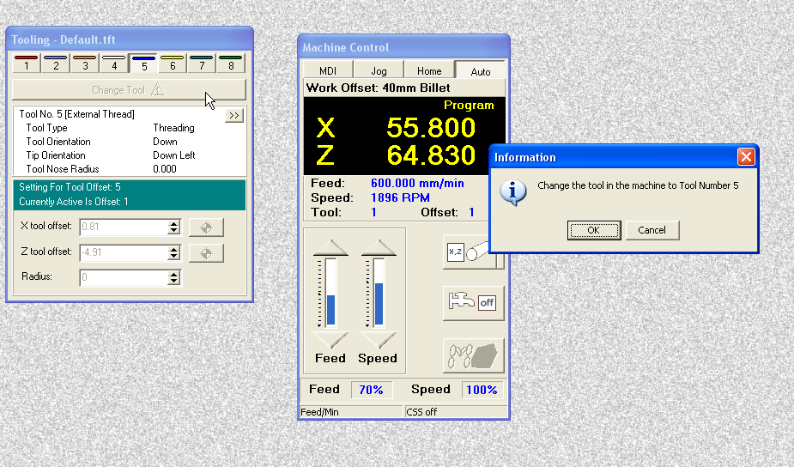

Select auto Mode

Click on tool 5 in the tooling library then select change tool. And click OK.

The tool will drive to the park position and you are prompted to change to the threading tool.

T5 will be displayed as the active tool in the control panel.

Now Select jog mode and jog the tip of the threading tool to the outside diameter of the bar to a position where it is level with the face. The tool is sitting in the Z0 position and the X diameter is that of the turned diameter.
In this position we will set both the X and the Z offsets.
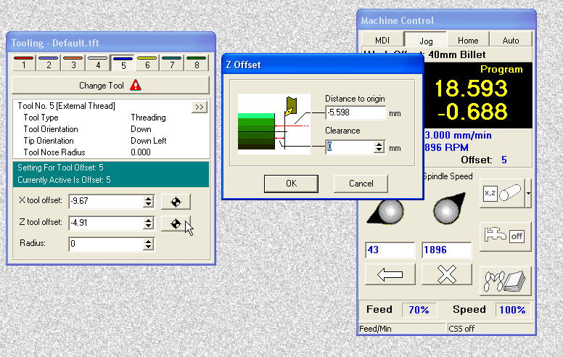

Click on the datum symbol to the right of the Z Offset display and then enter 0 in the clearance box and click OK.

The positional display will change to zero and the offset between tool 1 and the threading tool is recorded in the Z offset box.

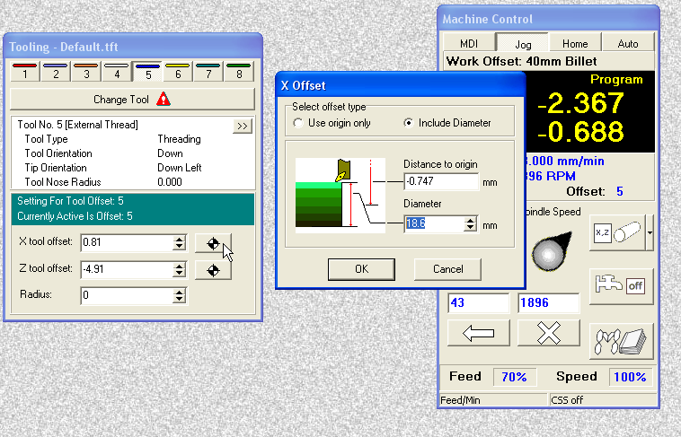
Now click on the datum symbol to the right of the X Offset display and then enter the measured diameter of the bar that the tool is touching onto.

This diameter will then be displayed as the program position and the offset from tool 5 is recorded in the X offset box.

Setting the parting tool
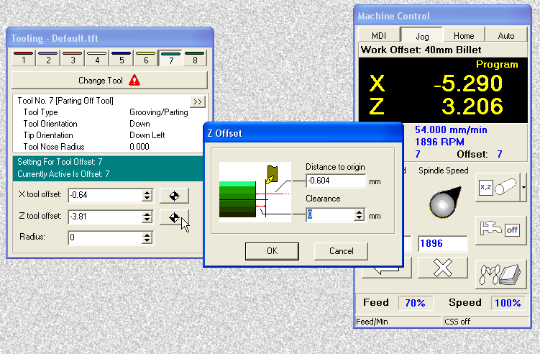

Change tool to the parting tool then in Jog mode take the parting tool blade up to the face of the billet. With the spindle turning jog very slowly until the face of the tool is touching the face of the billet. Then click on the datum symbol to the right of the Z Offset display and then enter 0 in the clearance box and click OK.

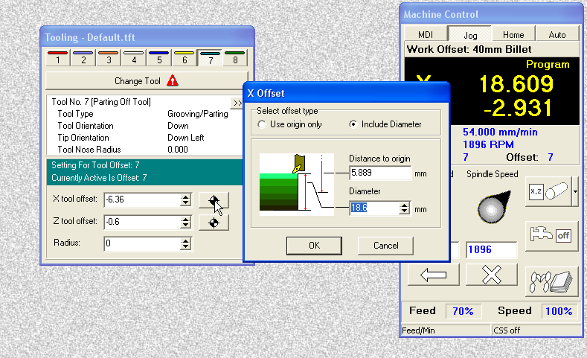
To Set the X offset jog the tool out and then touch the tip of the tool onto the turned diameter. At this point jog away in the Z axis only so that the tool is still at the same diameter as the bar. Stop the spindle. Open the guard and measure the diameter.

Now click on the datum symbol to the right of the X Offset display and then enter the measured diameter of the bar that the tool is touching onto.

This diameter will then be displayed as the program position and the offset from tool 7 is recorded in the X offset box.

