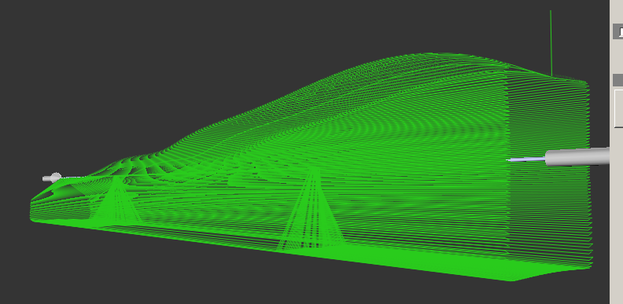

When this was put through QuickCAM 4D this hole appears in the cutting path
The initial drawing is for a flat bottom
I know it was suggested we put it through QuickCAMPRO but our head of dept. wants it to run with the 4th axis in place

Any comments would be appreciated

Phil Burton cad/cam technician

